Wang J., Li Y., Han Y.: 'Integrated modular motor drive design with GaN power FETs', IEEE Transactions on Industry Applications, 2015, 51, (4), pp. 3198-3207

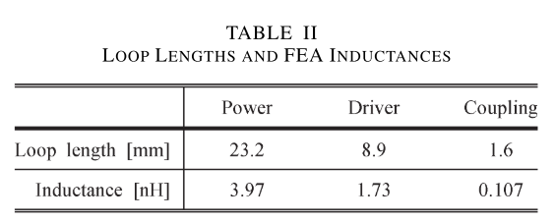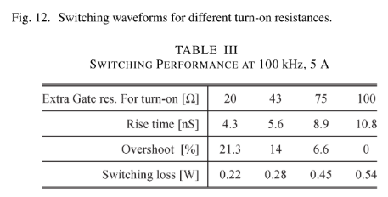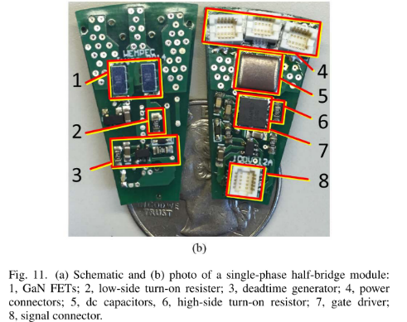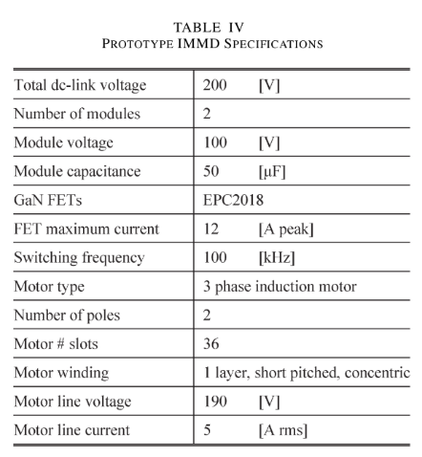

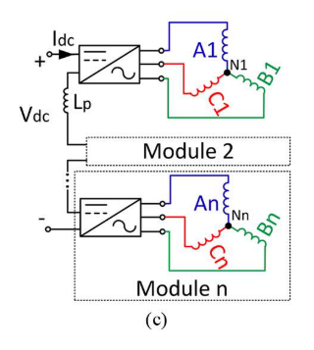

Engelmann G., Kowal M., De Doncker R. W.: 'A highly integrated drive inverter using directfets and ceramic dc-link capacitors for open-end winding machines in electric vehicles'. IEEE Applied Power Electronics Conference and Exposition, Charlotte, NC, USA, March 2015, pp. 290-296

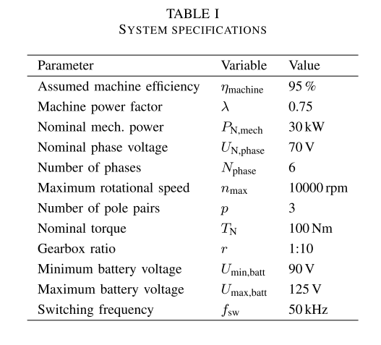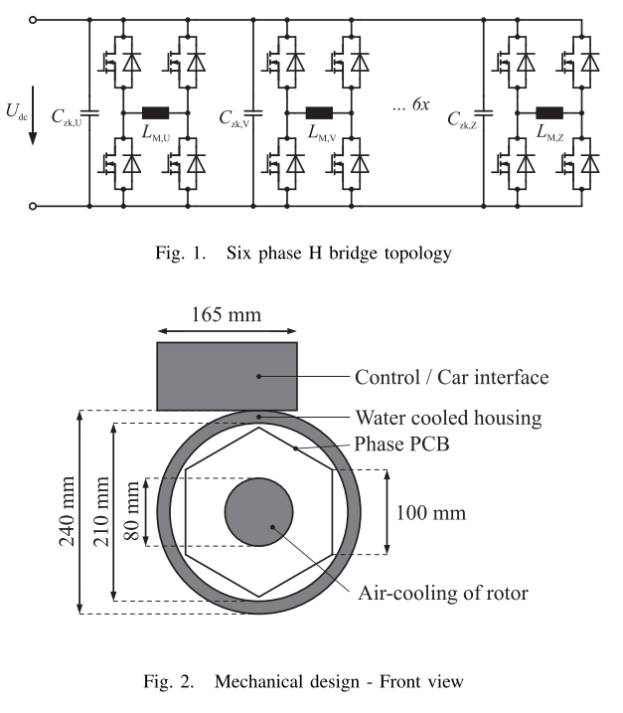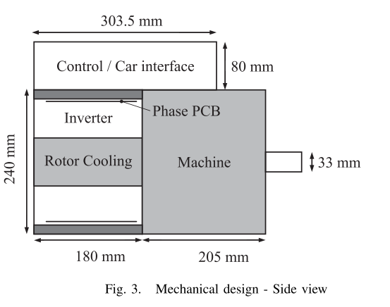

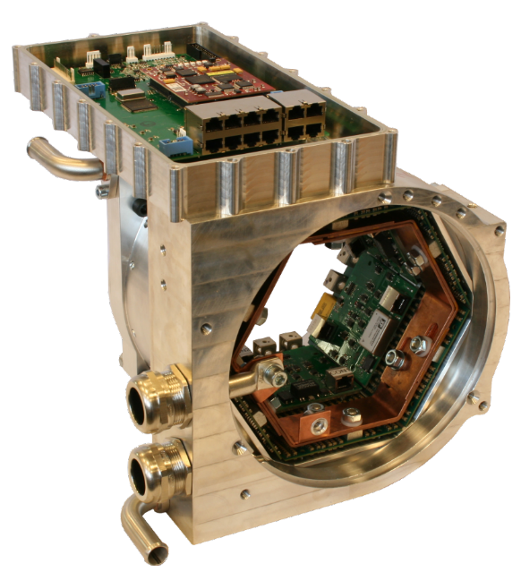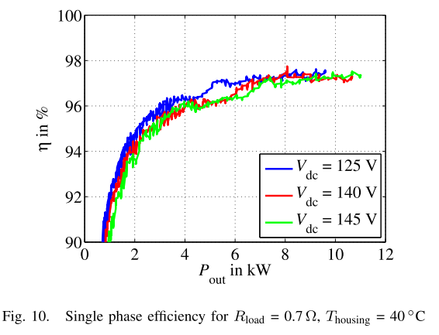

Shea A., Jahns T. M.: 'Hardware integration for an integrated modular motor drive including distributed control'. IEEE Energy Conversion Congress and Exposition, Pittsburgh, PA, USA, September 2014, pp. 4881-4887

18 kW, IGBT, 20kHz, 20uF, 22 nF

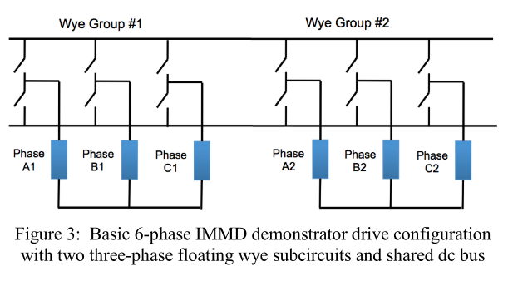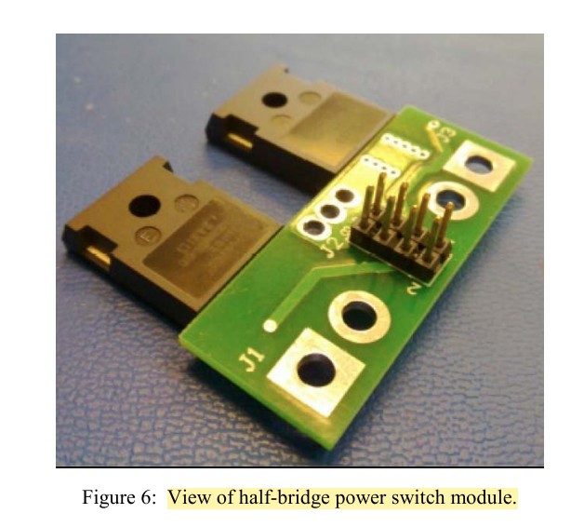

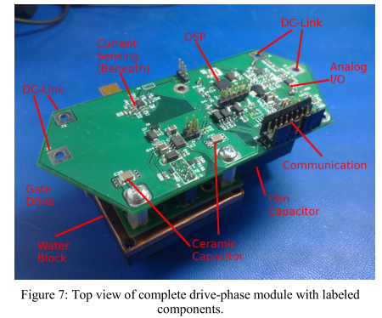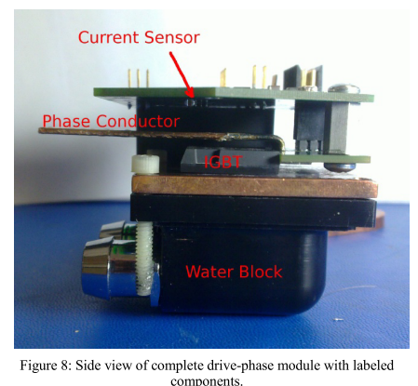

Hennen M. D., Niessen M., Heyers C., et al.: 'Development and control of an integrated and distributed inverter for a fault tolerant five-phase switched reluctance traction drive', IEEE Trans. Power Electron., 2012, 27, (2), pp. 547-554

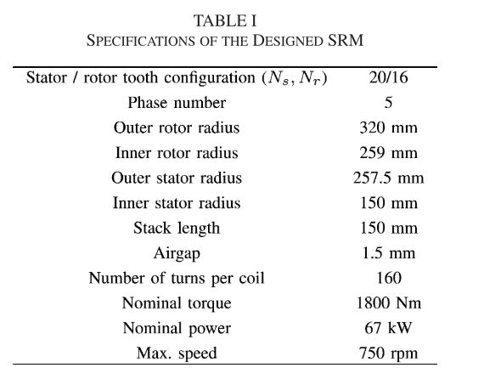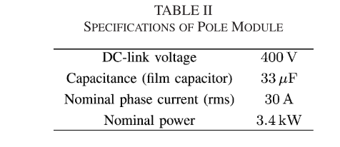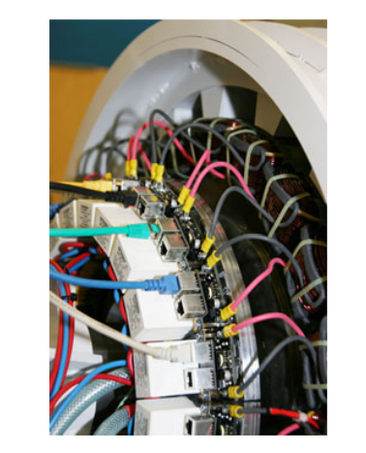

Brown N. R., Jahns T. M., Lorenz R. D.: 'Power converter design for an integrated modular motor drive'. IEEE Industry Applications Annual Meeting, New Orleans, LA, USA, September 2007, pp. 1322-1328

IGBT – 10 kHz